Ball Textures

Create by *Langvv*

Hi guys!

I have some textures to make cool effect. There are a lot of effect textures in this package.

* 20 ball
* 04 ball ring
* 06 light
* 04 star
* 17 plasma ball
* 07 sky effect
* 12 twirl ball

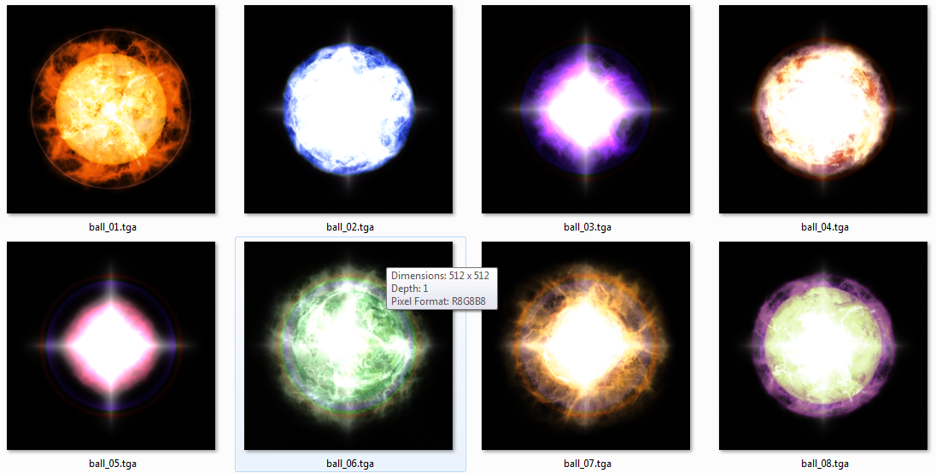

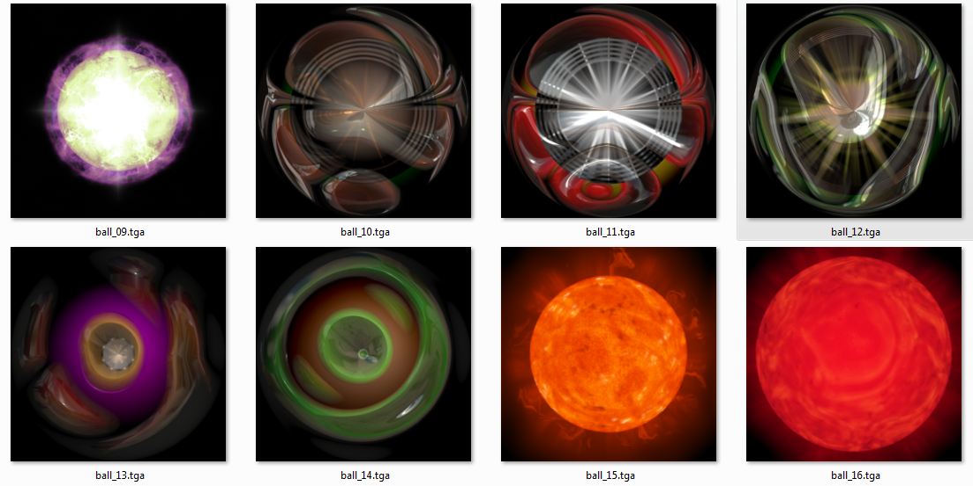

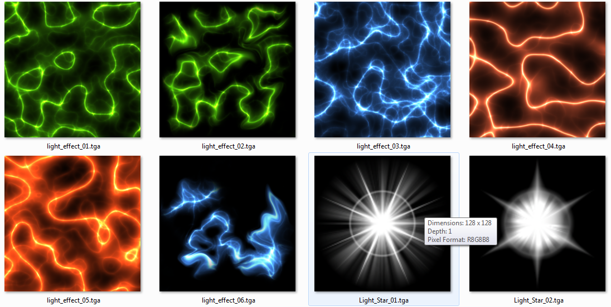

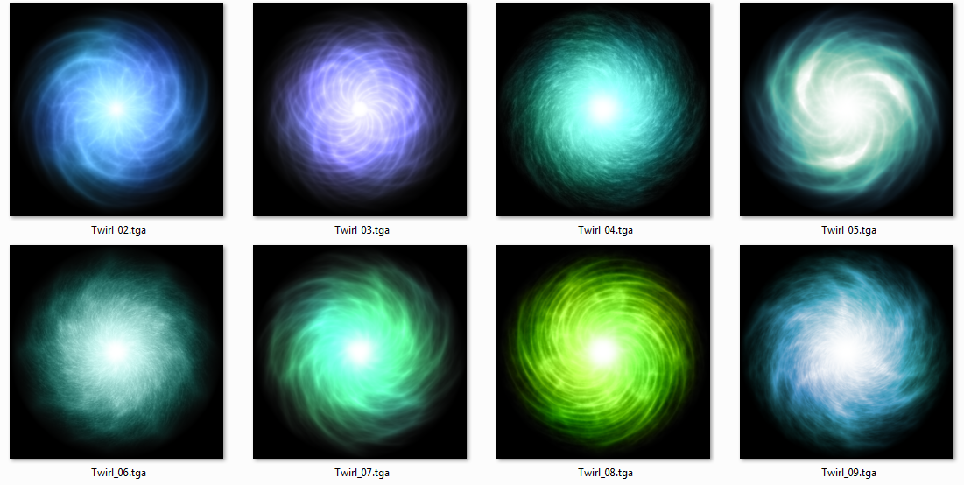

You can see on the demo scene, we have a ball effect. It has 5 elements

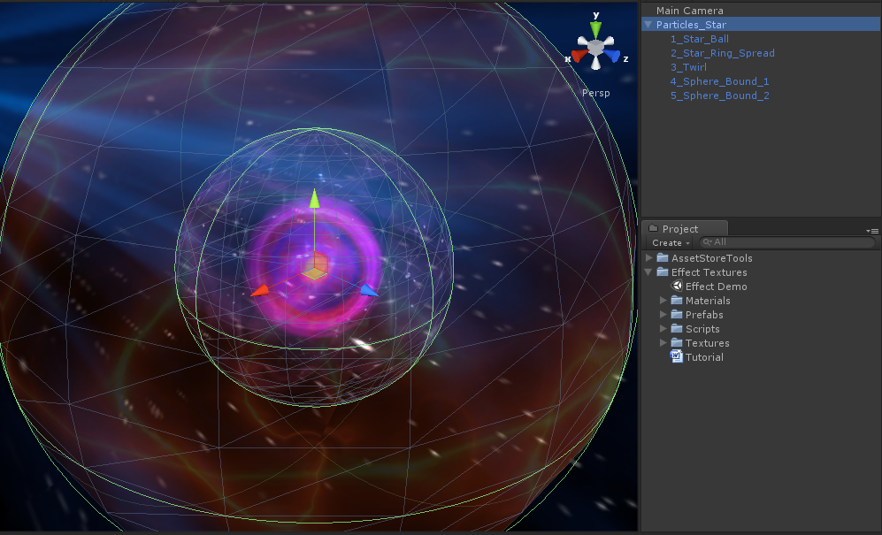

**1_Star_Ball** is a basic particle system

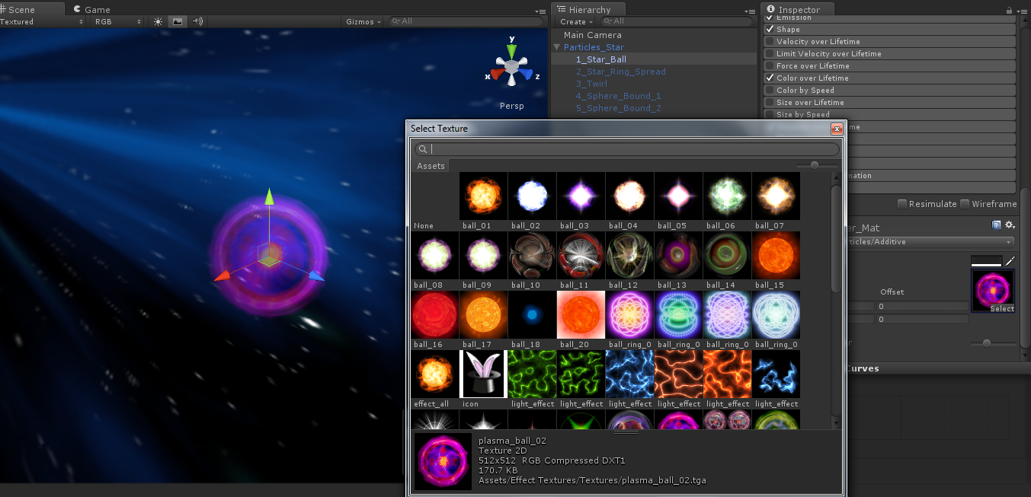

You can change texture to get other effect

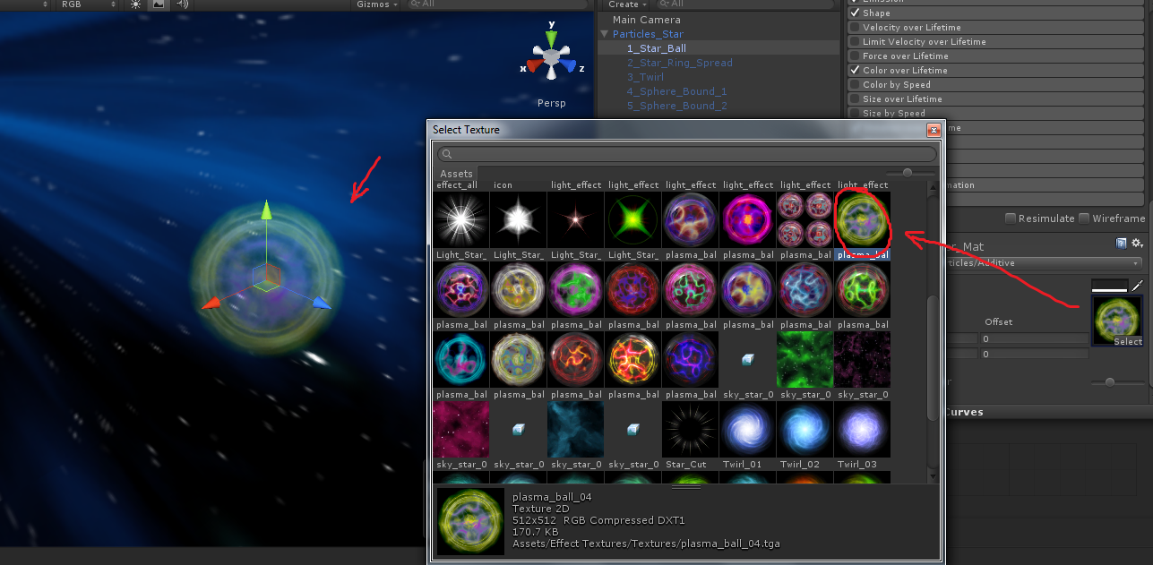

**2_Star_Ring_Spread** is a particle system

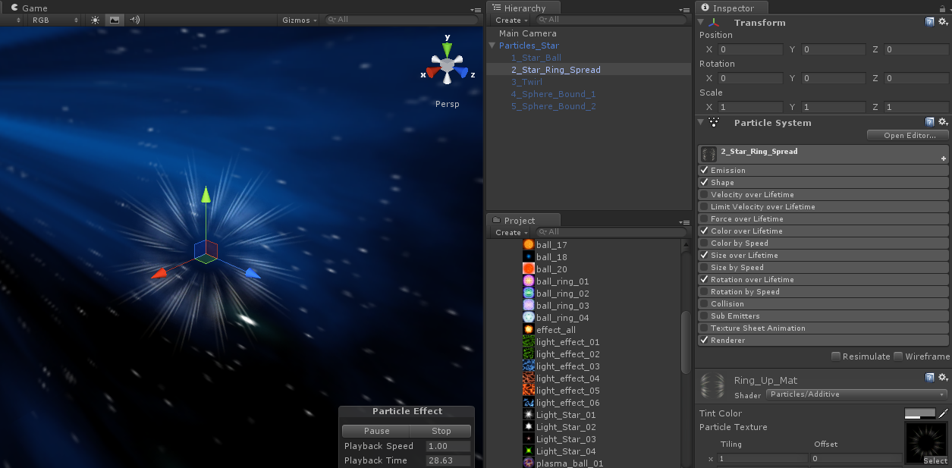

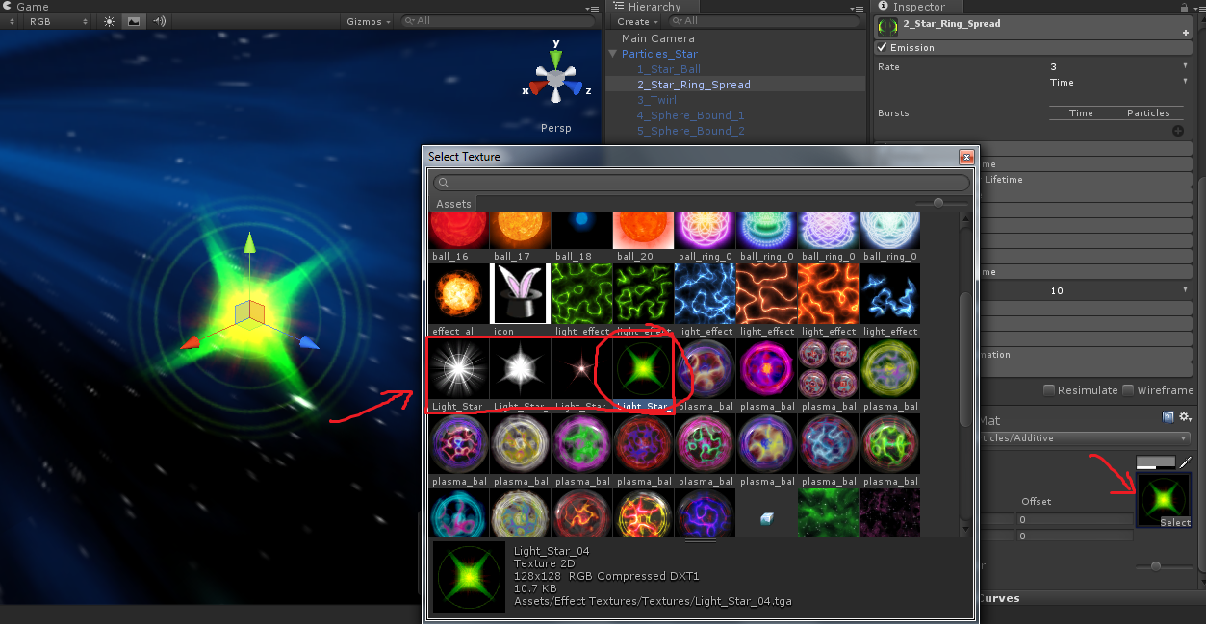

**3_Twirl** is a particle system

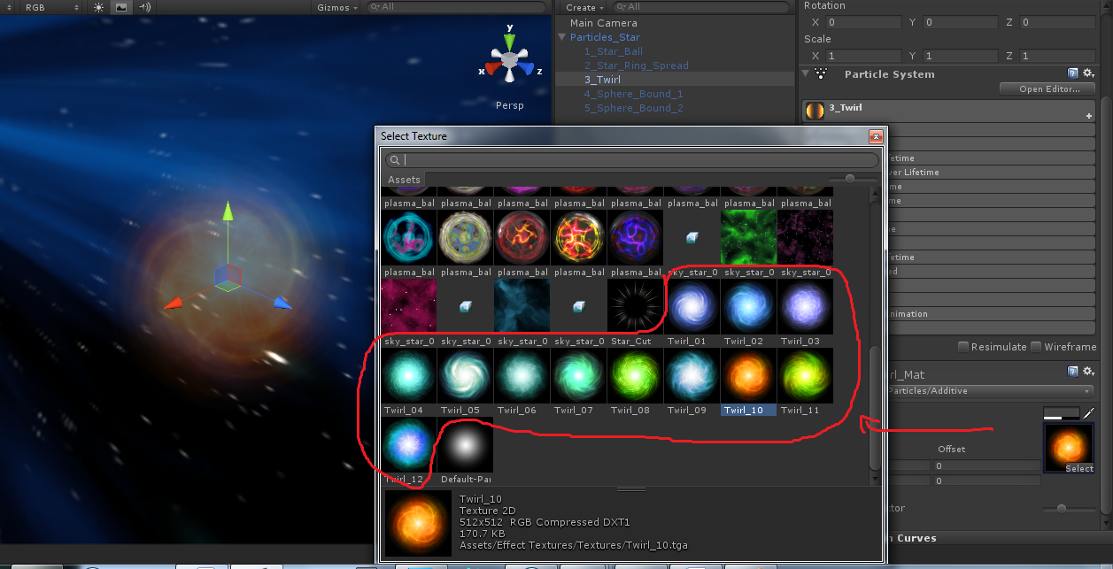

**4_Sphere_Bound_1** and **5_Sphere_Bound_2** are sphere meshs. You can change material to get some effects

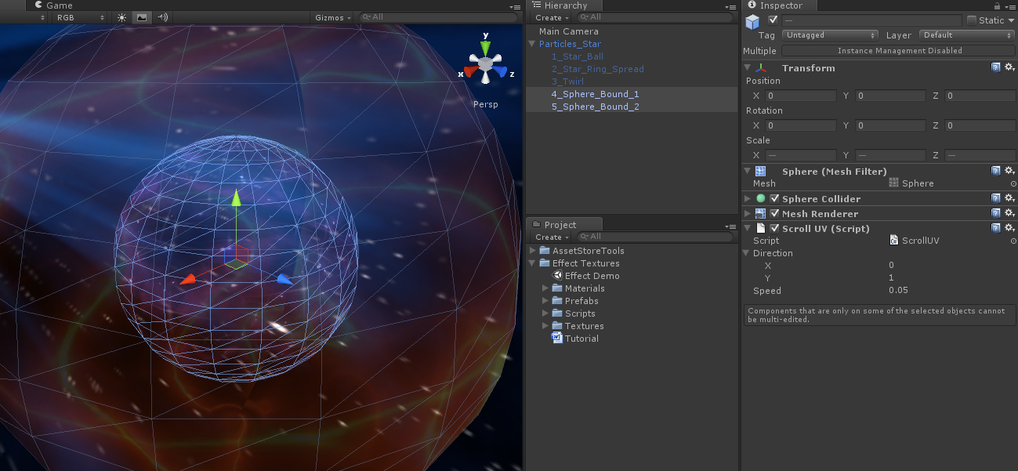

Example:

1. Select **1_Star_Ball** then change texture to:

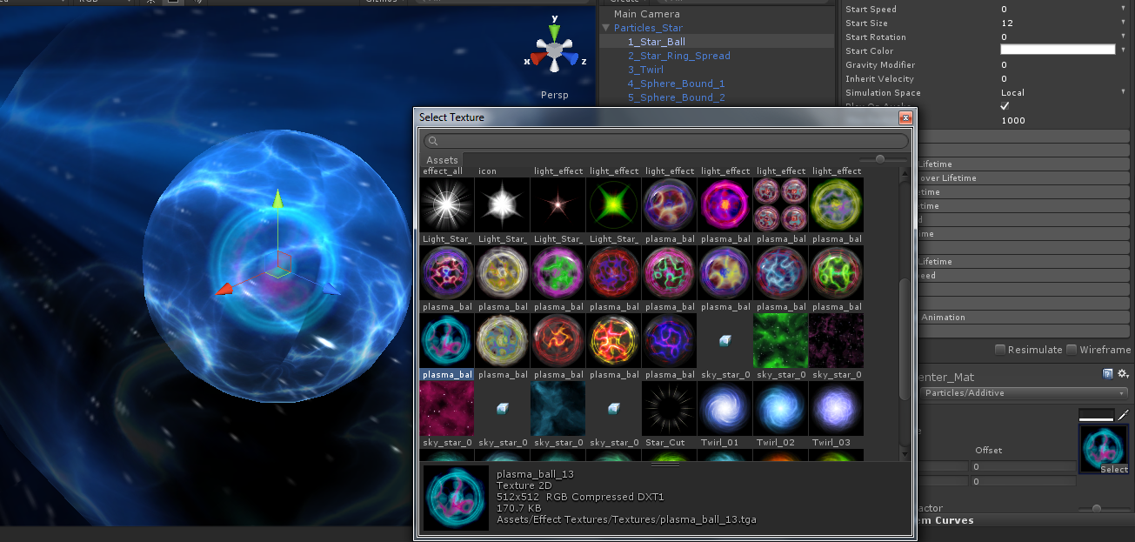

1. Select **2_Star_Ring_Spread** then change texture to:

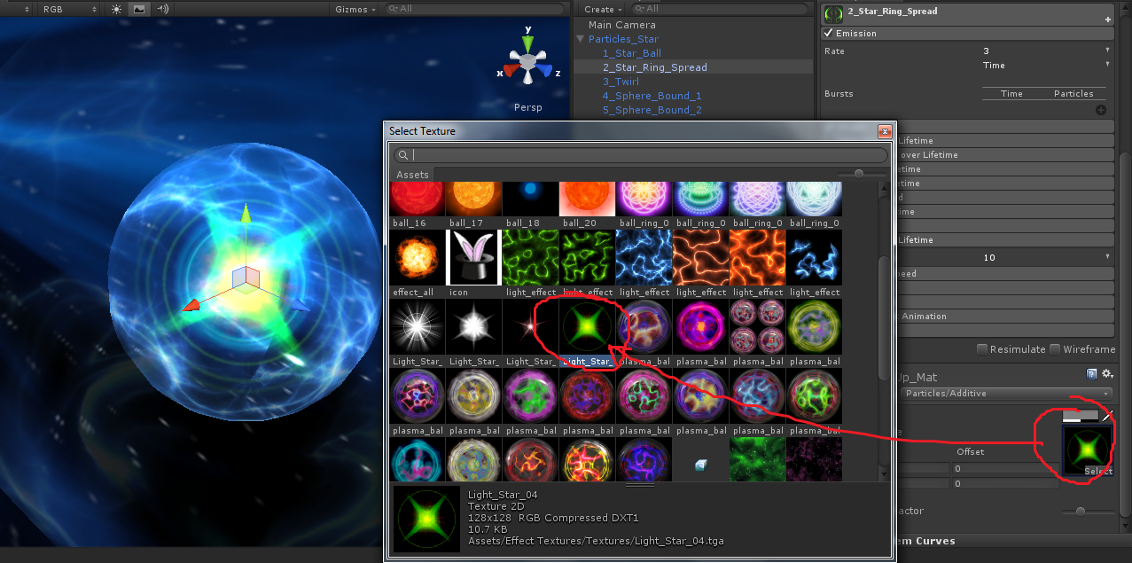

1. Select **3_Twirl** then change texture to:

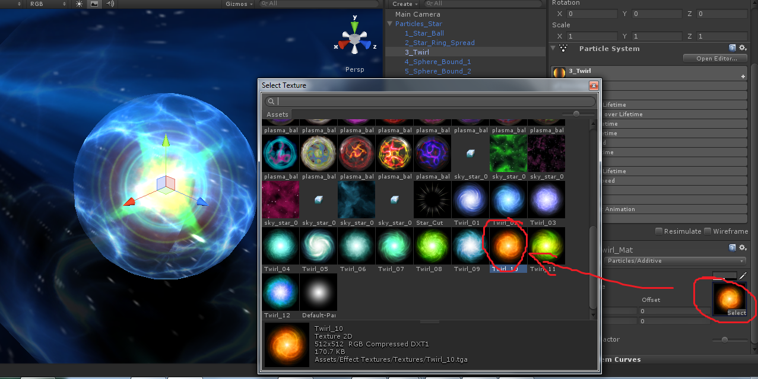

1. Select **4_Sphere_Bound_1** then change texture to:

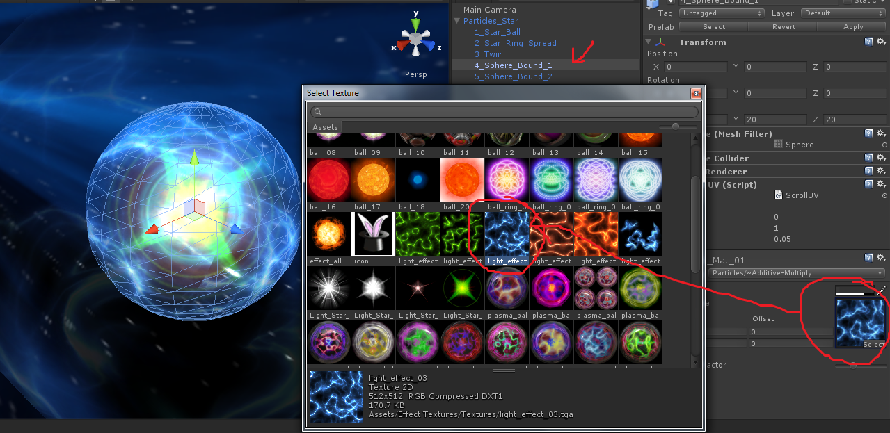

1. Select **5_Sphere_Bound_2** then change texture to:

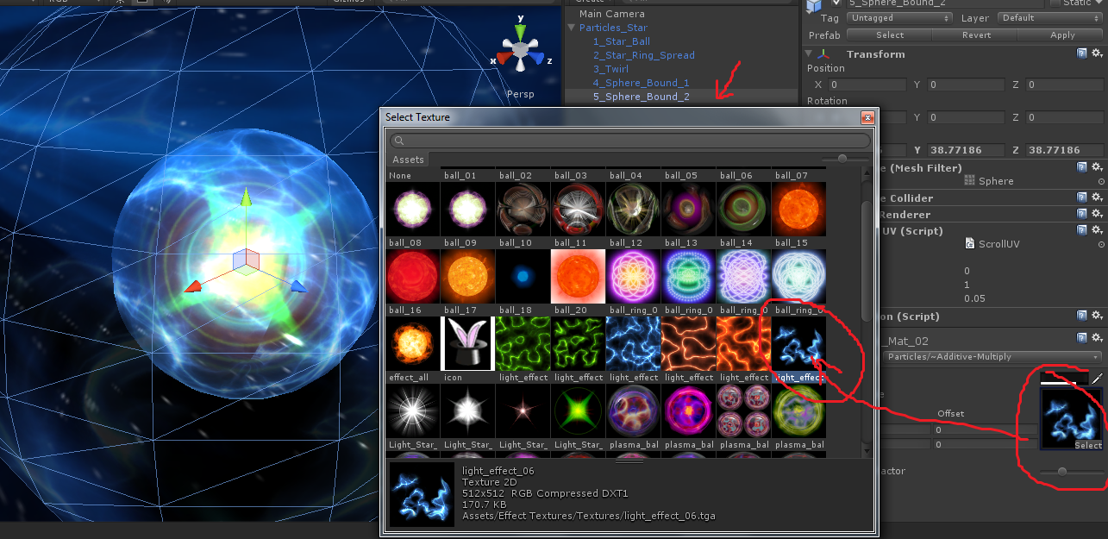

Result:

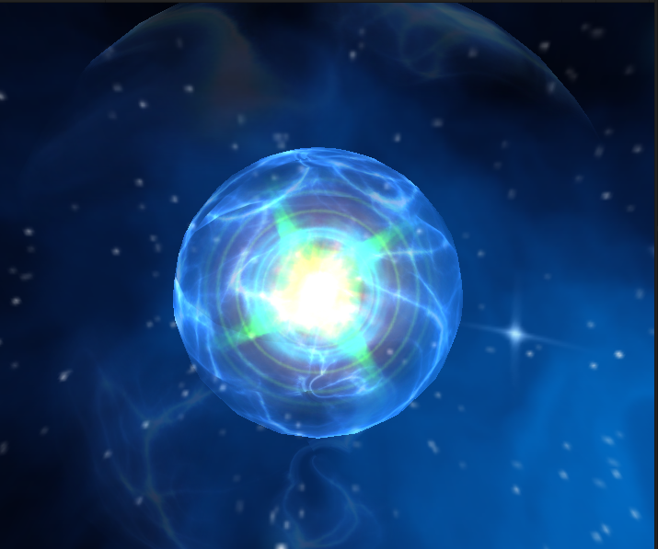

Thanks!